
Sanofi announces results from amlitelimab Ph3 SHORE and COAST 2 and Ph2 ATLANTIS 52 wk update in AD

Company: Sanofi  Drug: amlitelimab (SC OX-40L inhibitor) | Date: January 23, 2026  Source(s): Press release
What happened:
- Sanofi announced results of amlitelimab in Phase 3 SHORE (with background TCS ± TCI) and Phase 3 COAST 2 (monotherapy) in adults and adolescents with moderate-to-severe AD
  - SHORE met all primary and key secondary endpoints for both Q4W and Q12W dosing at Week 24 across both US and EU estimands with improvements as early as week 2
  - COAST 2 met the US primary endpoint (vIGA-AD 0/1 + ≥2-point improvement) for both Q4W and Q12W dosing but did not achieve statistical significance for the EU co-primary endpoints (vIGA-AD 0/1 and EASI-75)
  - Two additional phase 3 studies, AQUA and ESTUARY are anticipated to report results in H2 2026. Based on the totality of data, Sanofi will move forward with global regulatory submissions for amlitelimab. CI estimates approval in H2 2027
- Sanofi also shared preliminary Phase 2 ATLANTIS long term open-label data, which show continued improvement from Week 24 to Week 52, with amlitelimab well tolerated through Week 52

Impact (CI PoV): HIGH
- While studies met US specific endpoints with a potential path for regulatory submission in the US, the EU regulatory path remains unclear given COAST 2’s failure to meet the EU co-primary endpoints. Label expectations across geographies are also unclear, as COAST 2 failed under the EU estimand in the monotherapy setting, whereas SHORE met EU criteria in the presence of background topical therapy
  - Potential risk of US/EU label divergence

Why it matters:
- Topline follows September 2025 COAST 1 topline data, where amlitelimab monotherapy met primary endpoints but was viewed as underwhelming relative to current biologics
  - The addition of SHORE and COAST 2 does not materially change the efficacy profile, but rather strengthens confidence in reproducibility across study designs and reinforces dosing flexibility
- Sanofi believes novel fully human, non-T cell depleting OX40L MOA offers broad TH2/innate pathway coverage with durable, potentially remission-level efficacy, convenient Q12W dosing, and strong differentiation driven by unmet need
  - Per Sanofi, Phase 2 and Phase 3 data validate amlitelimab’s potential to deliver both Q12W dosing from the start and progressive efficacy through week 52
  - Management views amlitelimab as potential $2 billion to $5 billion product
Tell me more:
SHORE study
- Study design: Phase 3 randomized, double-blind, placebo-controlled, parallel-group, 3-arm trial for 12+ years patients with moderate-to-severe AD (combo with topical TCS ± TCI)
- Study Dose: Every 4 weeks (Q4W) or 12 weeks (Q12W) for 24 weeks
- Study Primary Endpoints: vIGA-AD 0/1 and a reduction from baseline score of ≥2 points (in the US, EU and Japan) and EASI-75 (EU and Japan only) at Week 24
- Results:
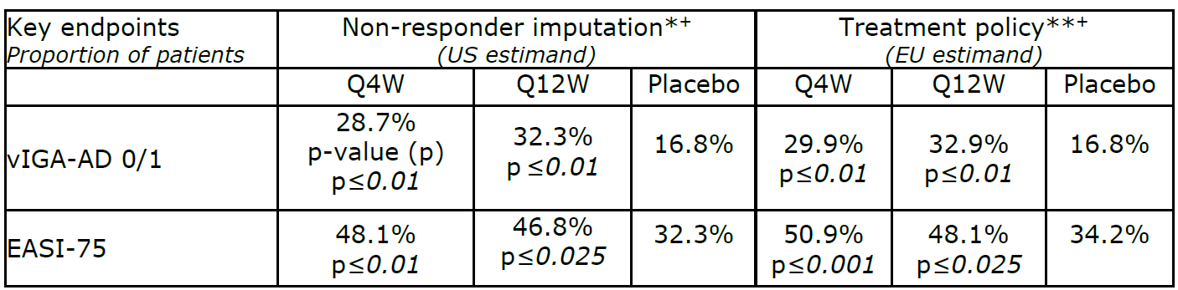

* Non-responder imputation: patients with rescue/prohibited medication use prior to week 24, or with missing week-24 data, are counted as non-responders ** Treatment policy: all data are included regardless of rescue medication use; however, patients with prohibited medication or missing week-24 data are still counted as non-responders
  - Most frequent treatment-emergent adverse events (TEAEs) reported (≥5%) included nasopharyngitis, upper respiratory tract infection, and atopic dermatitis; incidence of adverse events and TEAEs resulting in discontinuation were comparable between amlitelimab and placebo groups
COAST 2 study
- Study design: Phase 3 randomized, double-blind, placebo-controlled, parallel-group, 3-arm trial in 12+ years patients with moderate-to-severe AD (monotherapy)
- Study Dose: Every 4 weeks (Q4W) or 12 weeks (Q12W) for 24 weeks
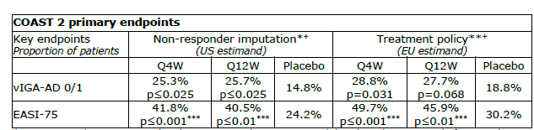
- Study Primary Endpoints: vIGA-AD 0/1 and a reduction from baseline score of ≥2 points (in the US, EU and Japan) and EASI-75 (EU and Japan only)
- Results:

* Non-responder imputation: patients with rescue/prohibited medication use prior to week 24, or with missing week-24 data, are counted as non-responders ** Treatment policy: all data are included regardless of rescue medication use; however, patients with prohibited medication or missing week-24 data are still counted as non-responders

  - The study met the US primary endpoint at week 24, however, did not achieve statistical significance for the US secondary endpoint assessing vIGA-AD 0/1 with barely perceptible erythema. In the EU analysis, neither dosing regimen reached significance for the co-primary endpoints (vIGA-AS 0/1 and EASI-75)
  - Most frequent TEAEs reported (≥5%) included nasopharyngitis, upper respiratory tract infection, and atopic dermatitis; incidence of adverse events and TEAEs resulting in discontinuation were comparable between amlitelimab and placebo groups
ATLANTIS study
- Study design: Phase 2 long-term open-label, single-arm, long-term safety study for 12+ years patients with moderate-to-severe AD
- Study Dose: Every 4 weeks (Q4W) for 268 weeks
- Study Primary Endpoints: TEAEs and TESAEs from baseline through the end of the study
- Results:
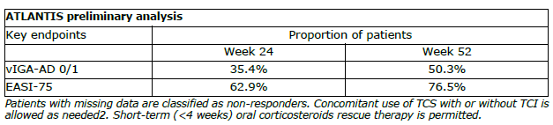

  - Preliminary results show that amlitelimab continued to improve skin clearance and disease severity from week-24 to week-52
  - Treatment well tolerated over the 52-week period
    - Most common TEAEs: nasopharyngitis, headache, influenza, dermatitis atopic, upper respiratory tract infection. Low serious TEAEs and TEAEs related discontinuations at Week 52 with an event of Kaposi’s sarcoma (cutaneous) reported in a patient with known risk factors

For questions, please reach out to:
 | Dermatology | Rheumatology | Gastroenterology
APEX (US/PCS) | Chanda Bhat | Bethany Christmann | Luke Versten
IMABI (International/ Affiliates) | Priti Anand | Irene Knorn | Priti Anand

Invite your colleagues to inVision | Manage Email Preferences | Unsubscribe

This document/email contains competitive intelligence collected via an approved competitive intelligence supplier working on behalf of AbbVie. We collect competitive intelligence consistent with industry standards and AbbVie policy. Not for field distribution. Please reach out to APEX/IMABI, Legal, or OEC teams with any questions.

